**Development of different URL’s for a REST API**

Alternative 1:

This is how the JSON document could look like.

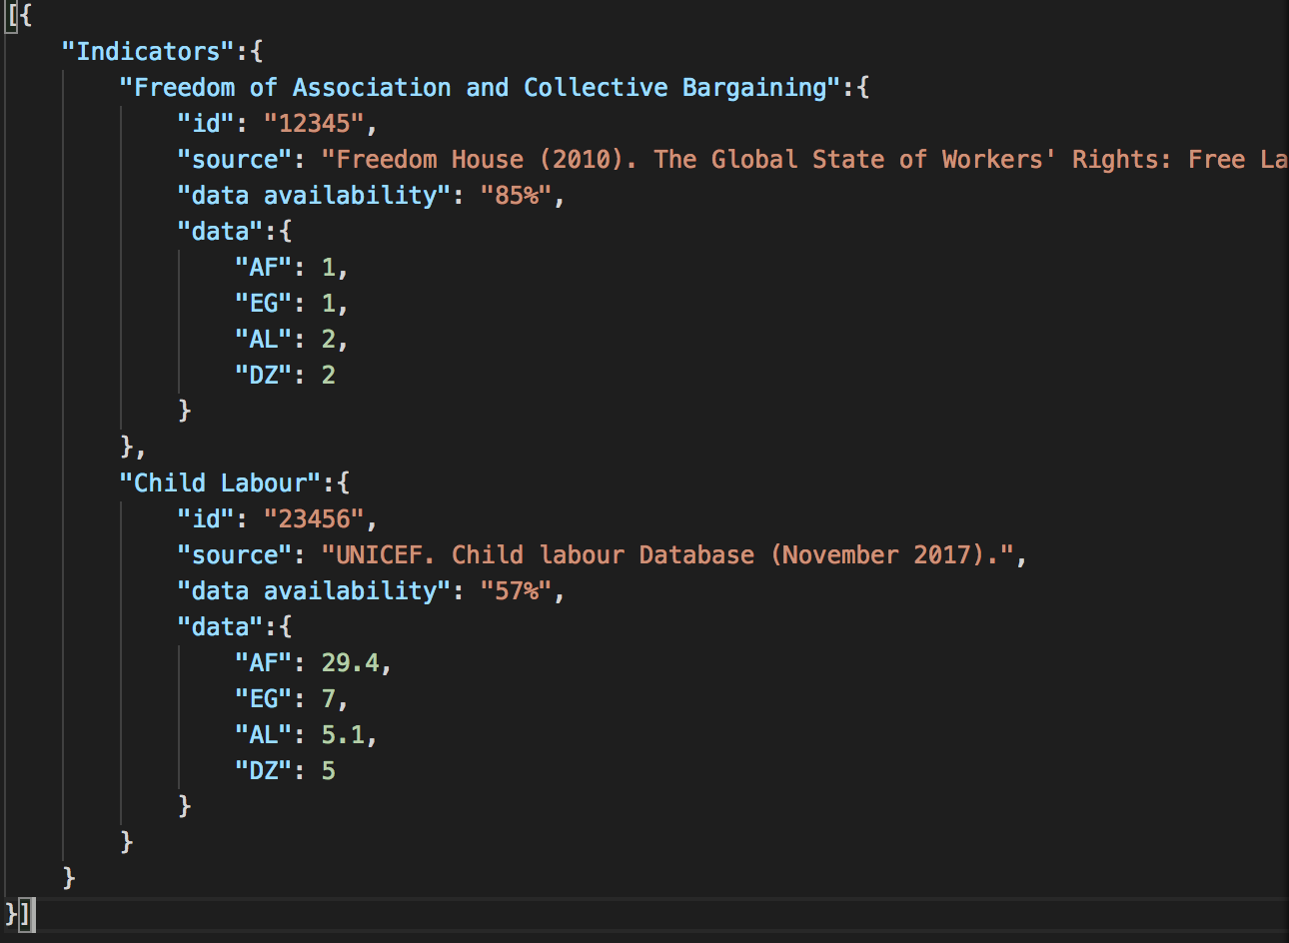

1. **…/Indicators**

Here only meta data to each Indicator is given back 🡪 “data” is excluded from the query.

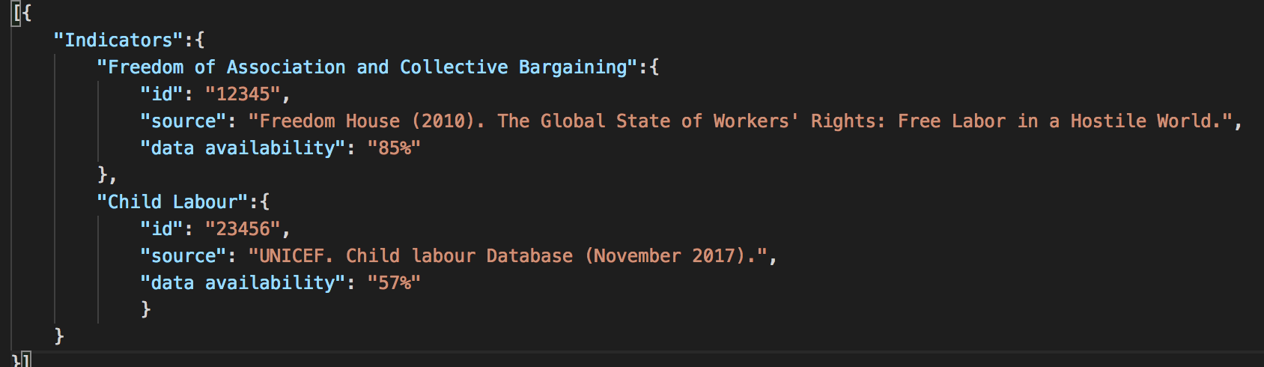

1. **…/Indicators/*”Indicator”***

Here all information regarding one specific indicator is given back.*🡪 z.B. …/Indicators/”Child Labour”*

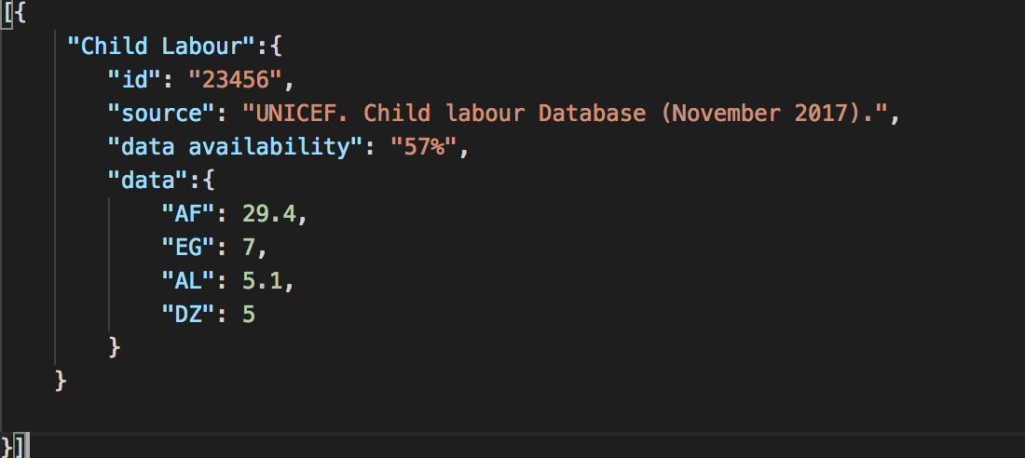

1. **…/api/Indicators/*”Indicator”/data***

Here the actual data values regarding one indicator is given back 🡪 z.B. …/Indicators/”Child Labour”/data

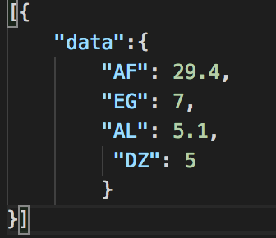

1. **…/api/indicators/*”indicator”*/data/*”country code”***

Here the data value for one specific country is given back for an indicator

🡪 z.B. …/Indicators/”Child Labour”/data/”AF”

**

Alternative 2:

This is how the JSON document could look like.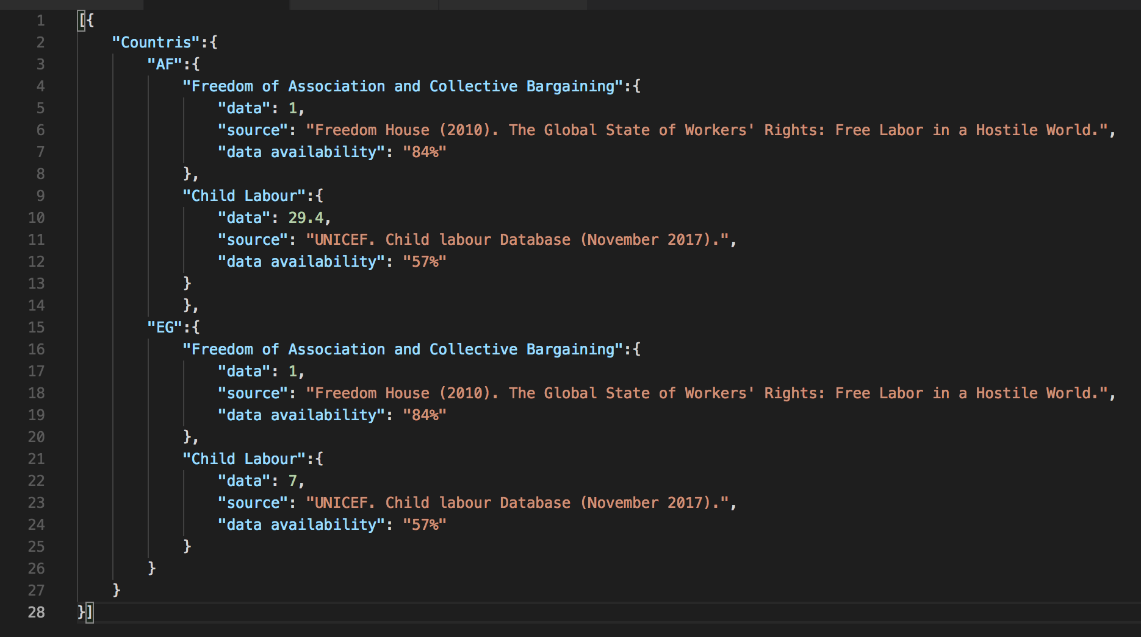

1. …/Countries
2. …/Countries/”County Code”
3. …/Countries/”County Code”/”Indicator”
4. …/Countries/”County Code”/”Indicator”/data

This approach does not seem useful because the meta information is saved for every data value and therefore inflates the size of the database.